# Machine Vision – Assignment 2 (Scene Reconstruction)

Name: Shane Quinn Date: 07/05/2021

Student Number: R00144107

## Task 1 (Pre-processing)

### A – Calibrate camera

Display checkerboard corners to subpixel accuracy. This was achieved using cv2’s findChessboardCorners and drawChessboardCorners methods

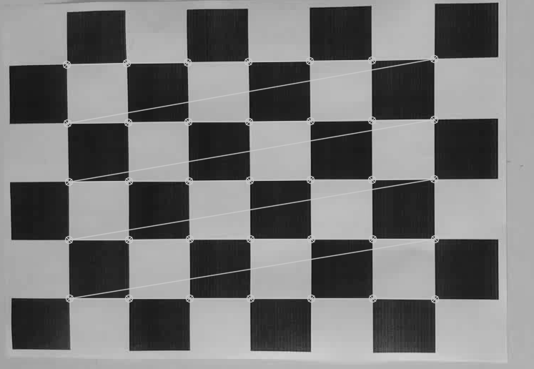 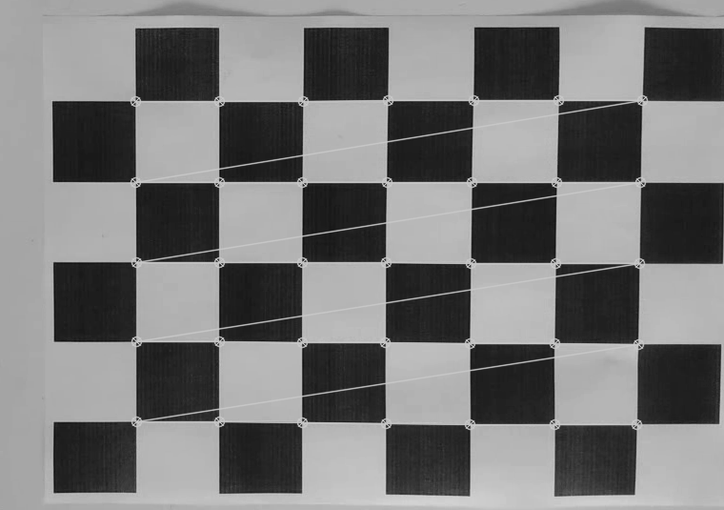

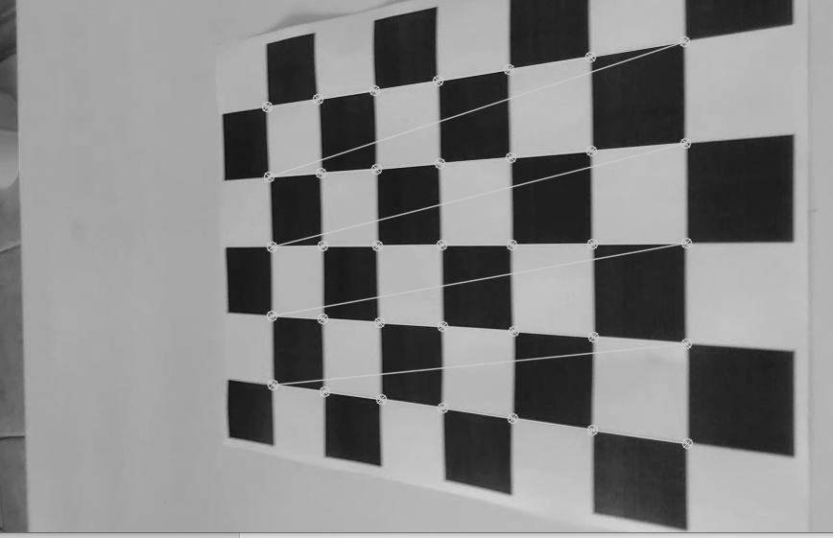 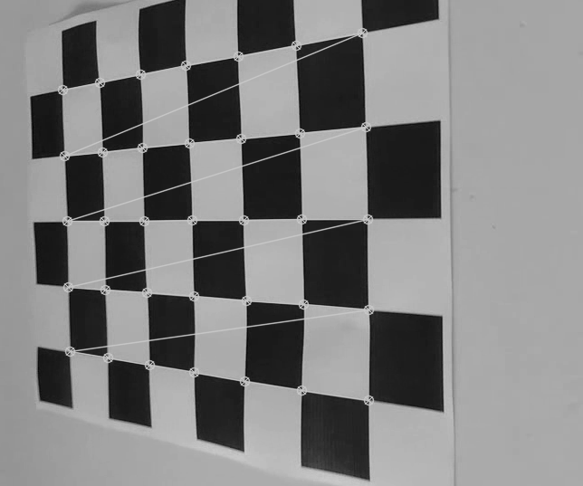

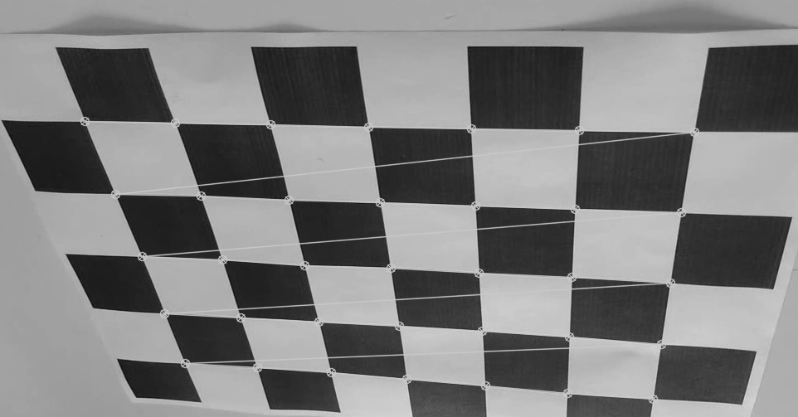 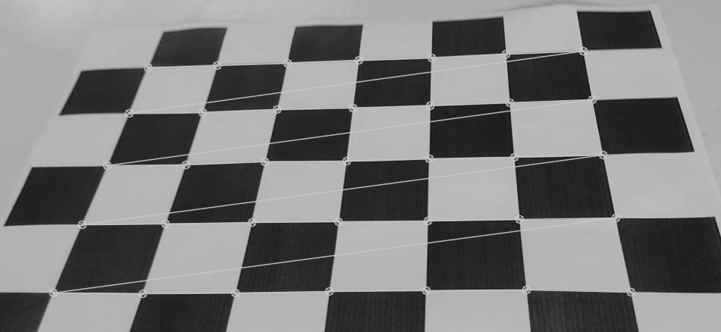

Figure – Checkerboard corners to subpixel accuracy.

### B – Calibration Matrix

Camera calibration Matrix 'K':

Principle length: 994.922868018294

Aspect ratio: 0.9586950306064169

Principle point: 1.6952886730694054

### C/D – Feature Extraction & KLT

Extracted 259 features using cv2’s goodFeaturesToTrack method. These were then refined to sub pixel accuracy. Then using the KLT algorithm we tracked each of these features through the image sequence.

## Task 2 (Fundamental Matrix)

### A – Visualize Tracks

Here we visualized the tracks on the sequence of images, tracks seen below in green. We also established correspondences between frame 0 and frame 30 using Euclidean normalized homogeneous vectors.

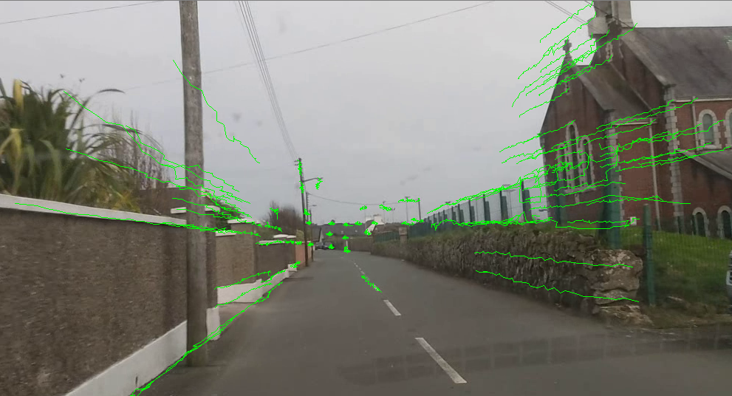

Figure – Visualise Tracks

### B – Mean/Standard Deviation

Using the correspondences found in the previous task we then calculated the mean and standard deviation. Then found normalized correspondences. Any correspondences not in both frame 0 and frame 30 were removed

### C/D – DLT algorithm – Fundamental Matrix

Using 8 random feature correspondences we calculated the fundamental matrix using the 80point DLT algorithm. Using normalized correspondences, we obtained the fundamental matrix.

Fundamental matrix:

### E/F/G/H – Model Equation

Using the remaining correspondences, we calculated the value of the model equation and it’s variance. Then using these values determined if each point was an outlier w.r.t. the fundamental matrix, setting the outlier threshold to 6.635. As this method relies on luck of the random points picked in the previous task, we repeated 10,000 times, saving the details of the run with the least outliers. Image below displays inliers(green) vs outliers (red) after the best iteration (total of 12 inliers).

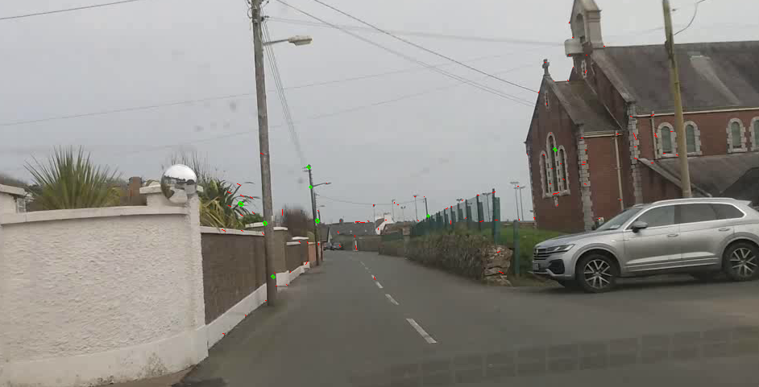

We then calculated the epipoles and displayed them on the image (below)

Epipole Co-ordinates F0: [493.38650335 314.95432672 1. ]

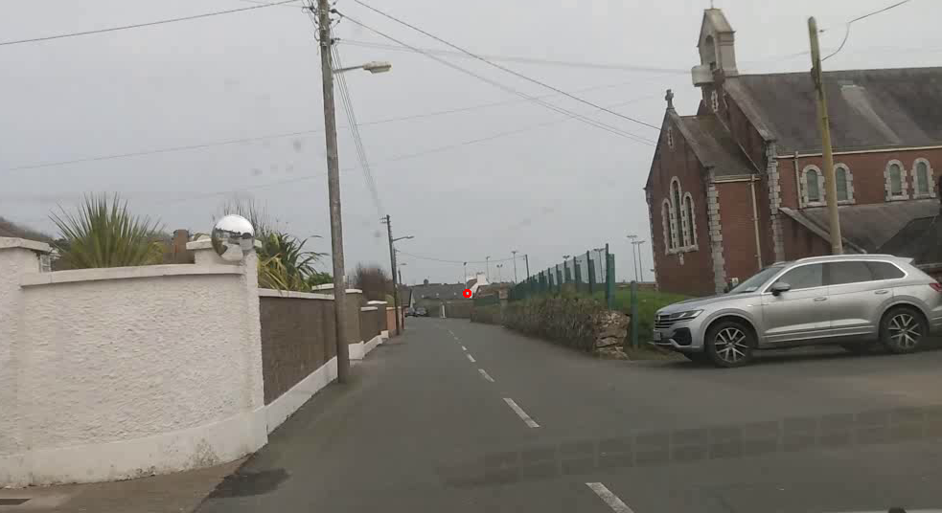

Figure – Epipole F0

Epipole Co-ordinates F30: [432.83235262 316.42497109 1. ]

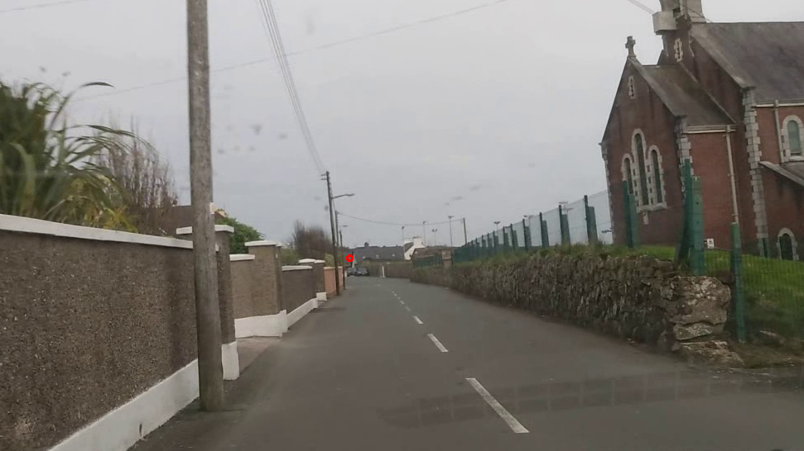

Figure – Epipole F30

## Task 3 (Essential Matrix)

Essential matrix derived from best performing Fundamental matrix:

Next determined the 4 rotation matrices Rt combinations.

Due to time constraints I was unable to complete the final 3 parts of Task 3